Server Hardware Maintenance & Monitoring Process

Version 1.0

Contents

Contents ii
1 4
Purpose 4
Scope 4
Required Technology 5
2 6
Daily Maintenance & Monitoring Process 6
i. Front panel LEDs Status: 6
ii. Rear panel LEDs Status: 7
iii. Hot-plug SCSI hard drive LEDs : 8
Monitoring Hardware Specific Events 8
installation steps 8
Plug and Play BMC Support 10
Creating the SMBIOS IPMI Device 11
Monitor Hardware with WMIC 14
Weekly/ Monthly Maintenance & Monitoring Process 15
Preventive Maintenance Procedures: 18
Contact Us 20

Document Information
This Document describes some of the items that you should check on a daily basis to help monitor the status of a Server system component. You must perform most of these checks consistently and archive the results over a period of time to obtain the greatest benefit

Purpose
Purpose of this document is to provide the steps involved in performing Daily, weekly and Monthly maintenance checks of the reliability, administration, security, and performance of a Server System

- Minimize disruption to the Client Access environment
- Maintain system performance
- Minimize administrative overhead
- Maximize "quick wins"
- Maintain system security

Scope
Scope is written below.

- Daily Maintenance Guideline
- Weekly/Monthly Maintenance Guideline
- OEM Utility
- BMC Features of windows
- WMIC
- Support

Required Technology

Table 1 lists the tools or technologies used in the procedures described in this guide. All tools should be accessed from an Operating System console, except in those cases where a link is provided.

Required Technology | Description | Location
Disk Defragmenter | Tool used to analyze volumes for fragmentation. Also used to defragment volumes. | Start > All Programs > Accessories > System Tools > Disk Defragmenter
System Monitor (formerly known as Performance Monitor) | Tool used to collect data on server health and performance | Start > All Programs > Administrative Tools > System Monitor
Event Viewer | Tool used to monitor and gather information on system, security, and application events | Start > All Programs > Administrative Tools > Event Viewer
OEM Utility | Tool used Access different utility of system component. | From OEM CD Pack or Web site.
BMC | The BMC monitors the state of the server hardware | Add/Remove windows components > Management and Monitoring >Hardware Management

Daily Maintenance & Monitoring Process

This Section provides detailed information about the processes that must be performed in order to maintain Server Physical Components.

Check Lists Detail | Check  (Y/N)
To be checked Daily
Check Front panel LEDs of server | Y/N
Check Front panel LEDs of server | Y/N
Check Hot-plug SCSI/SATA hard drive LEDs | Y/N
Check Processor zone fan module LED | Y/N
All external cables and power cables should be firmly plugged in. | Y/N
Monitor Hardware Specific Events in event viewer (BMC) | Y/N
Check Power Cord and UPS | Y/N
Monitor the Server Room Temperature | Y/N

Front panel LEDs Status:

Following Tables shows the status of LEDs

Item | Description | Status
1 | Power On/Standby button  and system power LED | Green = System is on.  Amber = System is shut down, but power is still applied.  Off = Power cord is not attached, power supply failure has  occurred, no power supplies are installed, facility power is not  Available, or the DC-to-DC converter is not installed.
2 | Internal health LED | Green = System health is normal.  Amber = System is degraded.  Red = System critical.  Off = System health is normal (when in standby mode).
3 | External health LED  (power supply) | Green = Power supply health is normal.  Amber = Power redundancy failure occurred.  Off = Power redundancy failure has occurred. When the server is  in standby mode, power supply health is normal.
4 | NIC 1 link/activity LED | Green = Network link exists.  Flashing green = Network link and activity exist.  Off = No link to network exists.

Rear panel LEDs Status:
Following Tables shows the status of LEDs

Item | Description | Status
1 | iLO activity | Green = Activity exists.  Flashing green = Activity exists  .  Off = No activity exists.
2 | NIC activity | Green = Link exists.  Flashing green = Activity exists.  Off = No link exists
3 | External health LED  (power supply) | Green = Power supply health is normal.  Amber = Power redundancy failure occurred.  Off = Power redundancy failure has occurred. When the server is  in standby mode, power supply health is normal.
4 | NIC 1 link/activity LED | Green = Network link exists.  Flashing green = Network link and activity exist.  Off = No link to network exists.

Hot-plug SCSI hard drive LEDs :

Following Tables shows the status of LEDs

Item | Description | Status
1 | Activity status | On = Drive activity  Flashing = High activity on the drive  .  Off = No drive activity
2 | Online status | On = Drive is part of an array and is currently working.  Flashing = Drive is actively online.  Off = Drive is offline.
3 | Fault status | On = Drive failure  Flashing = Fault-process activity  Off = No fault-process activity

Monitoring Hardware Specific Events
This section highlights the steps involved in getting the feature installed and enabled on windows 2003.

installation steps
In Windows Server 2003 , you can install Hardware Management is available from the Management and Monitoring Tools section of the Add/Remove Windows Components Wizard
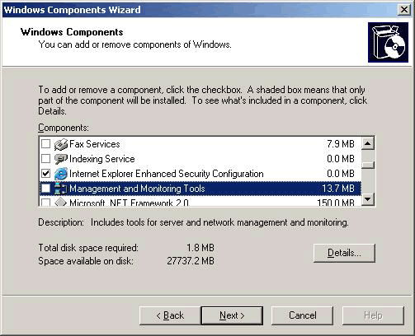
- In Control Panel, select Add or Remove Programs.
- Select Add/Remove Windows Components.
- Select Management and Monitoring Tools and press the Details button to bring up the following window.
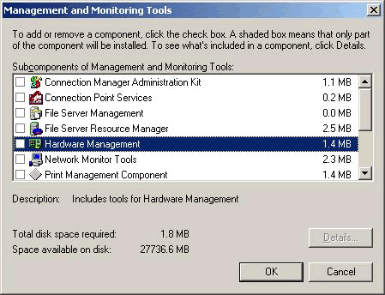
- Choose the Hardware Management option. If a BMC is detected via the SMBIOS Table Type 38h, the following dialog box will be displayed:
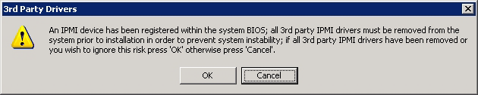
- If no 3rd party IPMI drivers are installed or they have been removed from the system, press the OK button to continue. Otherwise, press the Cancel button, remove the 3rd party IPMI driver and reinstall the Hardware Management Component.
- Press the OK button to select the Hardware Management Component, and then press the Next button. Hardware Management (including Win RM) will be installed.

Plug and Play BMC Support
The IPMI driver supports ACPI (Plug and Play). To fully support this feature, however, the BMC resources must be exposed via ACPI by the system’s BIOS. This capability may be supported in new systems or from a BIOS upgrade. If the BMC is detected via Plug and Play, you will notice an Unknown Device appear in Device Manager before the Hardware Management component is installed.
If the BMC resources are exposed properly via ACPI, the Windows Plug and Play infrastructure will detect the hardware and automatically install the IPMI driver. A new device, named Microsoft Generic IPMI Compliant Device, will appear in Device Manager, as shown below:
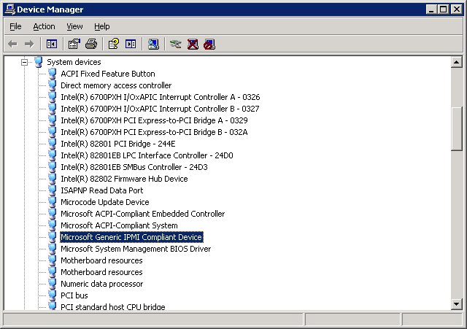

Creating the SMBIOS IPMI Device
If your system does not automatically detect the BMC via Plug and Play and install the driver, but a BMC was detected during the setup process, the BMC device must be manually created.
To create the IPMI BMC device, execute the following command from a command prompt:
Rundll32 ipmisetp.dll, AddTheDevice
Once this command is executed, the IPMI device will be created and can be seen under the Device Manager as Microsoft Generic IPMI Compliant Device. The device will be removed when the Hardware Management component is uninstalled.

When you install the Hardware Management component of Windows Server 2003 or Windows Server 2008, two new event logs are created in the Windows Event Viewer, Forwarded Events and Hardware Events, as shown below:
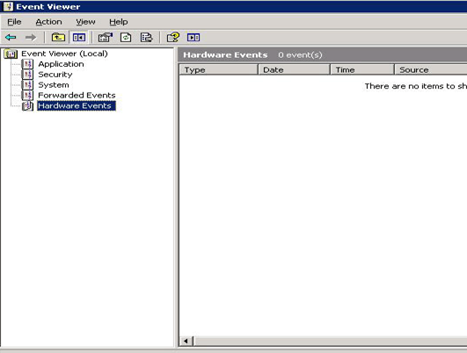
The Event Collector service is a Windows Remote Management client that is used to create subscriptions to WS-Management event providers and store the events received in the Windows SEL. Two scenarios are supported in R2 and Windows Server 2008.
- Logging of hardware events from the local SEL when the operating system is running ("in-band"), using the IPMI driver and WMI provider.
- Logging of hardware events from a remote server’s BMC using WS-Management (when BMC hardware supports this).
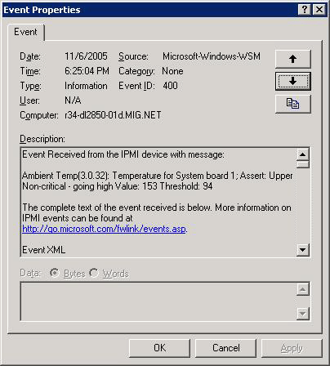
Windows Server 2003 R2 and Windows Server 2008 use a component called the System Event Log (SEL) plug-in. The SEL plug-in and the Event Collector subscribe to events stored in the BMC’s SEL.
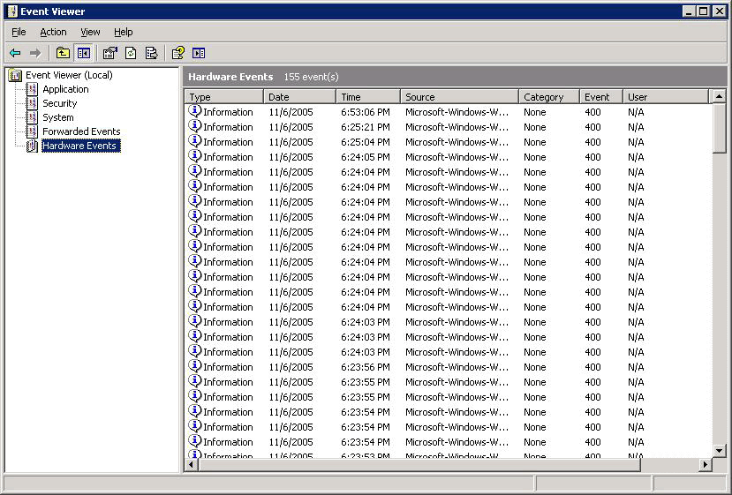
In case of an operating system shutdown or failure, Windows logs IPMI events into the BMC’s SEL. The administrator can then access the BMC's SEL using "out-of-band" tools to determine why a machine is not running.

Monitor Hardware with WMIC

1. Open Command Prompt

2. Type Following Command to get information of System Hardware Components.

- 1. Base board (also known as a motherboard or system board) management.

C:\ WMIC BASEBOARD

- 2. Basic input/output services (BIOS) management

C:\ WMIC BIOS

- 3. CPU management

C:\ WMIC CPU
C:\>wmic cpu get Name
C:\>wmic cpu get NumberOfCores, NumberOfLogicalProcessors

- 4. Basic input/output services (BIOS) management

C:\ WMIC BIOS

- 5. Physical system enclosure management.

C:\ WMIC SYSTEMENCLOSURE

- 6. Uninterruptible power supply (UPS) management

C:\ WMIC UPS

- 7. Voltage sensor (electronic voltmeter) data management

C:\ WMIC VOLTAGE

- 8 . Management of physical connection points including ports, slots and peripherals, and proprietary connections points.

C:\ WMIC SYSTEMSLOT

- 9. Management of common adapter devices built into the motherboard (system board).

C:\ WMIC ONBOARDDEVICE

- 10. Interrupt request line (IRQ) management

C:\ WMIC IRQ

- 11. IDE Controller management

C:\ WMIC IDECONTROLLER

- 12. Interrupt request line (IRQ) management

C:\ WMIC IRQ

- 13. Physical disk drive management

C:\ WMIC IDISKDRIVE

- 13. SCSI Controller management

C:\ WMIC SCSICONTROLLER

Weekly/ Monthly Maintenance & Monitoring Process

This Section provides detailed information about the processes that must be performed in order to maintain Server Physical Components.

Check Lists Detail | Check  (Y/N)
To be checked Daily
Check the Backup Media | Y/N
Test the Server with OEM Diagnostic Utility | Y/N
Check Logs from OEM Integrated Management Log | Y/N
Check all Hardware with server Diagnostics for Windows Utility | Y/N
Check All external cables and power cables should be firmly plugged in. | Y/N
Monitor the Server Room Temperature | Y/N
Update All your Drivers | Y/N

Update All Your Drivers
Up to date drivers means your hardware runs at peak performance. Up to date drivers means more bugs have been fixed, and your system will have fewer crashes. Up to date drivers mean new features and configuration options are unlocked in your devices, particularly with video cards. To update your drivers, you’ll have to refer to the official website of each of your hardware and look for the related drivers.
Usually, we’ll keep our eye on the drivers for:
- Graphic cards
- Motherboard (chipset)
- Sound Card
- Network card
- Keyboard and Mouse
- Monitor
Power Supply Voltages
Verify that the voltage-select switch (if applicable) is set for the correct voltage. If the power-on indicator is not on, and if the power-supply fan is not running, check the power cord for proper installation and continuity. If the power cord is OK, either the power supply is defective or a defective device is causing the power supply to shut off. Check the power supply voltages.
OEM Diagnostic Utility:

Almost every OEM has its own diagnostics utility for their Server Maintenance and Monitoring. Below Table shows the common components can be managed and monitored through OEM utility . Generally this utility come with server hardware or can be downloaded with OEM respective web site.

Feature | Description | OEM Tools
Advanced Diagnostic Tests | Identifies most problems associated with the following major components:  - System board  - Hard disk drives  - Diskette drives  - CD-ROM drives  - RAM  - Serial and parallel ports  - Video adapter  - Printer  - Keyboard  . Mouse | - HP Diagnostics Tool  http://welcome.hp.com/country/us/en/support.html?pageDisplay=drivers  - IBM Dynamic System Analysis (DSA)  http://www-947.ibm.com/support/entry/portal/docdisplay?lndocid=SERV-DSA

Diagnostics for Windows Features

Diagnostics for Windows is a set of diagnostic tests, including tests for system and processor components, memory and storage elements, ports, and input/output devices. The Diagnostics for Windows is supplied on the hp Startup CD-ROM. To install Diagnostics for Windows, follow the instructions on the README file located in the Diagnostics for Windows folder on the Startup CD-ROM. Diagnostics for Windows is run under Windows. When you start the utility, an Overview screen displays the current configuration of the hp server. Menus and tabs allow you to perform in-depth tests and access detailed hardware and software information by category (system, input devices, communication, and so on). Diagnostics or Windows does not use any tests that might write over and destroy user data. Components tested with Diagnostics for Windows include:

You can use Diagnostics for Windows to perform the following tasks:
• Display the current server configuration.
• Run a high-level Quick Test of basic hardware components.
• Run a Complete Test to thoroughly test basic components.
• Run a Custom Test to select specific test variations.
• Run tests in Interactive or Unattended mode.
• View, save, and print test results and the test error log.
• View, save, or print a summary of this sessions tests and results.
• Display and print information for specific hardware and software categories.

About Error Messages
A hexadecimal number designates each error message reported by Diagnostics for Windows. Sometimes the message includes a short note regarding the type of error and a list of one or more steps you may take in response. Most of these errors are encountered rarely, if ever. Error codes can be viewed in the Error tab within Diagnostics for Windows.

• System board • Processor
• Memory modules • Hard disk drives (HDD)
• Flexible disk drive (FDD) • Keyboard
• Parallel ports • CD-ROM drives
• Video monitor
• Multimedia devices
• Communications devices

Preventive Maintenance Procedures:

Refer to the following table for preventive maintenance procedures used for the server. Be sure to turn off power to the server when cleaning it.

S.No | Preventive Maintenance Activity | Recommended Frequency
1 | Scan hard disk file systems for errors | Daily
2 | Clean CRT screen | Weekly
3 | Defragment hard disks | Weekly
4 | Scan for hard disk read errors | Weekly
5 | Clean mouse | Monthly
6 | Check for full hard disk volumes and remove unnecessary files | Monthly
7 | Check power protection devices to ensure they are still protecting the system | Quarterly
8 | Check power supply fan for ventilation and dirt buildup and clean if necessary | Quarterly
9 | Back up CMOS information | Quarterly
10 | Update emergency boot floppies | Quarterly
11 | Clean floppy disk drive internals and read/write heads | Quarterly (depending on use)
12 | Check processor temperature, inspect heat sink and fan to ensure they are working | Annually (or whenever case is opened)
13 | Check hard disk for temperature and vibration | Annually (or whenever case is opened)
14 | Clean exterior of case | Annually
15 | Clean exterior of monitor | Annually
16 | Check and clean interior, motherboard and expansion cards if necessary | Annually
17 | Check internal connections and cables | Annually
18 | Clean keyboard | Annually

Document Change History

Table 2: Document Change History
Version Number | Description of Changes | Author | Comments
1.0 | Server Maintenance & Monitoring Process Document | Ramanuj Prasad Singh | Remark 27/5/2011
Source: Comviva

